Week 9 - Final WESO Practice

Part A - Computing Basics (10 points)
1) What is the name of the unit that executes instructions and performs calculations in a computer?
a. CPU
b. Input
c. Memory
d. Output

2) What is the name for something that connects computers together so that they can share data?
a. Hard Drive
b. Algorithm
c. Network
d. Operating System

3) Which one of the following is NOT a programming language?
a. Scratch
b. Python
c. Java Script
d. Flow Chart

4) Which of the following is NOT a computer peripheral?
a. Keyboard
b. Random Access Memory
c. Webcam
d. Printer

5) What is the name for an error in a computer program that makes it function incorrectly?
a. variable
b. sprite
C. bug
D. mouse

Part B - Computing “Theory”

1. Convert 89 from decimal to binary.

a. Show your steps for conversion. (3 pts.)
b. Write the final answer and circle it. (2 pts.)

2. Convert the binary number 11011 to decimal.

a. Show your steps for conversion (3 pts.)
b. Write the final answer and circle it (2 pts.)

3. There is a farm that has cows, chickens, and goats. They want to install a system that will sort the animals into their respective pens when they come in from the pasture. The animals will enter one at a time and stand on a scale. Depending on their weight, the correct door will open--one to the chicken coop, one to the cow barn, and one to the goat barn. The chickens all weigh between 6 and 12 pounds, The goats are all 60-100 pounds, and the cows all weigh at least 300 pounds.

Draw a flowchart to show how the system will work. Keep in mind you can only have one animal on the scale at a time. (5 pts)

Part C - Practical Computing

Make Pong!

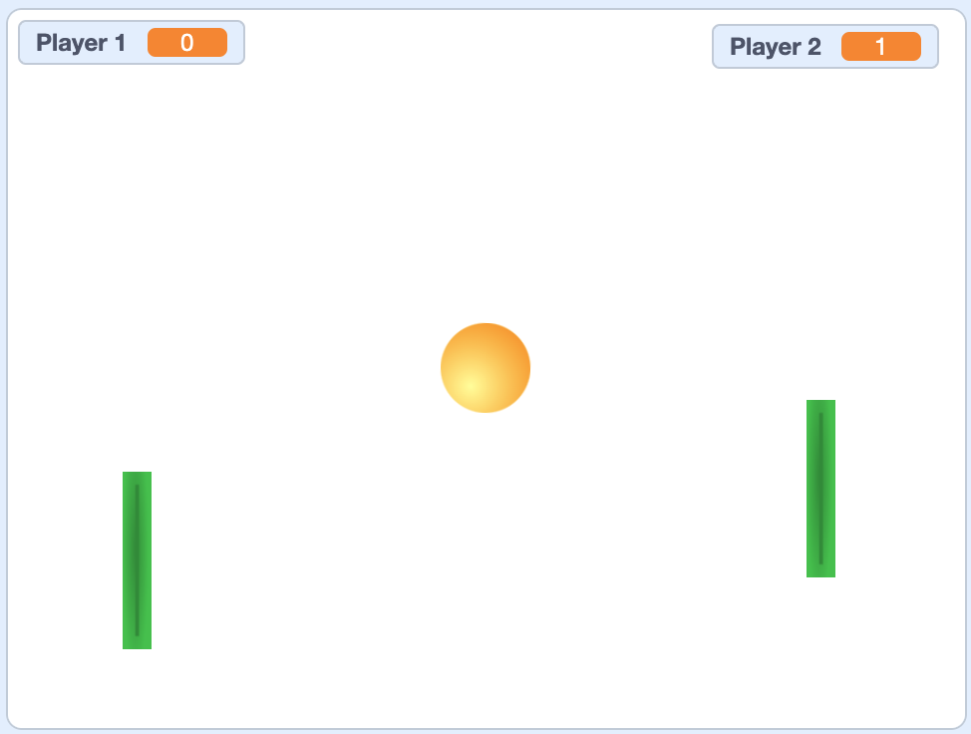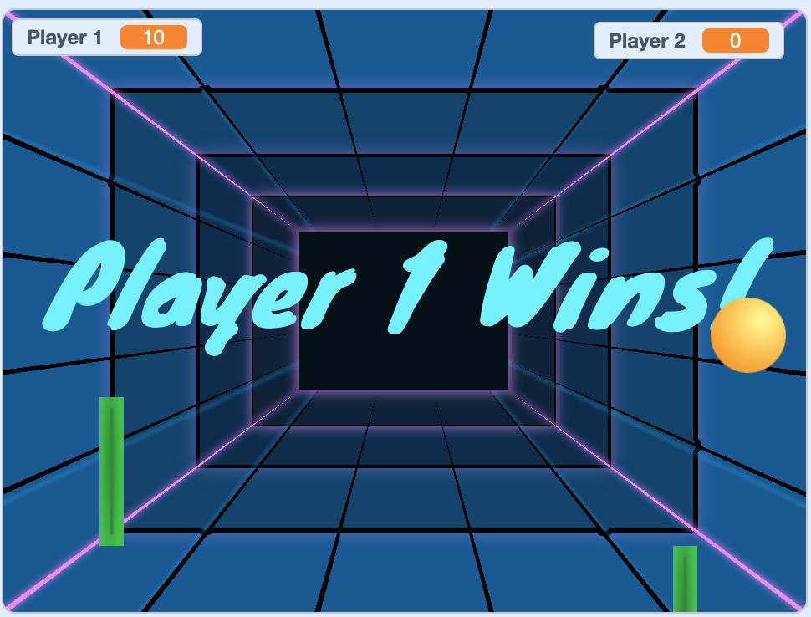
Requirements:
- Ball starts in the center and goes in a random direction.
- If ball hits the top or bottom wall it bounces like a real ball would.
- If ball hits either player’s paddle it bounces like a real ball would.
- If a ball gets past a player, the other player gets a point, which is shown on the scoreboard.
- When one player gets 10 points, the game is over. All sprites should stop and the background should congratulate the winner.

Extra credit:
- Some ball starting directions result in pretty boring games. Figure out what a “good” range for starting directions would be and make sure the ball can only start within that range (or ranges).
- If the each player hits the ball a certain number of times (say, 5 each), make the game more challenging by speeding the ball up slightly. It should speed up every time the chosen number of hits is reached (e.g., every 5 hits, it gets faster).

